**Notes of Mobile Computing**

**__________________________________________________________________**



|  |  |
| --- | --- |
| **Compiled by:** | **Course Professor:** |
| **Name:** Saad Ishtiaq  **Roll no:** BSEF18A025 | Professor Haq Nawaz |

***(DO NOT COPY.*** *This property belongs to***Saad Ishtiaq.*)***

**Punjab University College of Information Technology,**

**PUCIT (Old Campus),**

**LAHORE**

**بِسْمِ اللهِ الرَّحْمٰنِ الرَّحِيْمِ**

"In the name of God, the Most Gracious, the Most Merciful"

**اَللَّهُمَّ إِنِّي أَسْأَلُكَ عِلْمًا نَافِعًا, وَ رِزْقًا طَيَّبًا, وَ عَمَلاً مُتَقَبَّل**

”O Allah, I ask you for knowledge that is of benefit, a good provision and deeds that will be accepted.”

  [Ibn Majah and others]

In this dua, we ask Allah for three things;

* knowledge that is beneficial
* deeds that will be accepted
* provision that is pure

**Version Control Systems**

**What will we learn?**

* Version Control Systems
* Concepts like Online Editing and Merge Conflicts
* Different cmd commands
* git-add
* git-commit
* git-status
* git-push
* git-pull
* git-log
* git rm
* git-branch
* git-checkout
* git-merge

**(Note:** Don’tpanic!You can do it easily.**)**

**It is wriiten in quran:**

**“**Allah does not charge a soul except [with that within] its capacity.**”**

**Surah:** Al-Baqara **Ayah:** 286

**Version Control Systems:**

**What is VCS:**

**Version control** is a **system** that records changes to a file or set of files over time so that you can recall specific **versions** later. Using a VCS also generally **means** that if you screw things up or lose files, you can easily recover.

**Why do we need it:**

* To keep track of changed to code.
* To make same code available to all members working on a project.
* To synchronize code between groups.
* To test changes without losing original files.
* To revert back to old version.

Now we know about the VCS. Lets practically dive into it. But, before starting kindly understand that these notes are made in step by step format. Steps with screenshots are attached with proper explanation. Just follow the steps and you will get everything done.

Having said that Buckle up!



Do Following Steps:

1. Go to github website (<https://github.com/>) and sign for free.

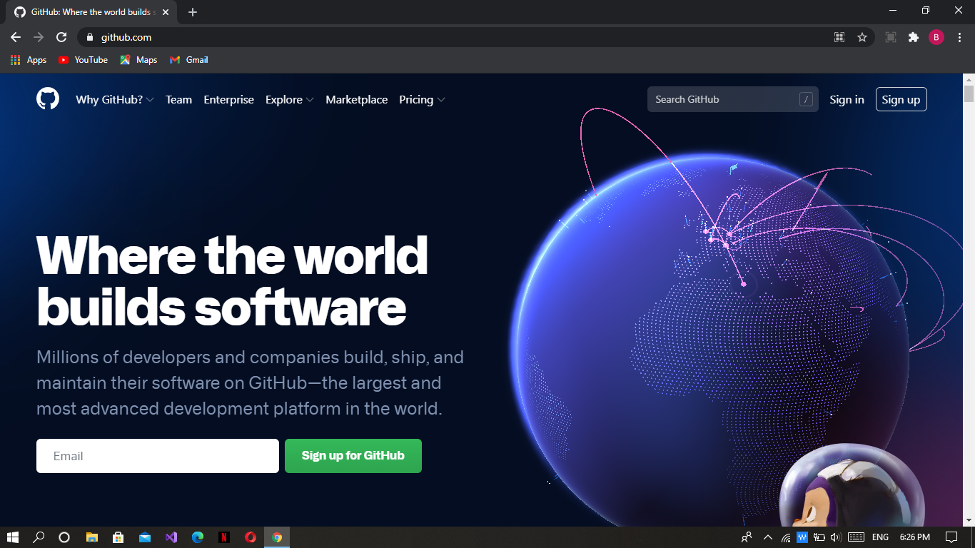

1. Make a new repository.

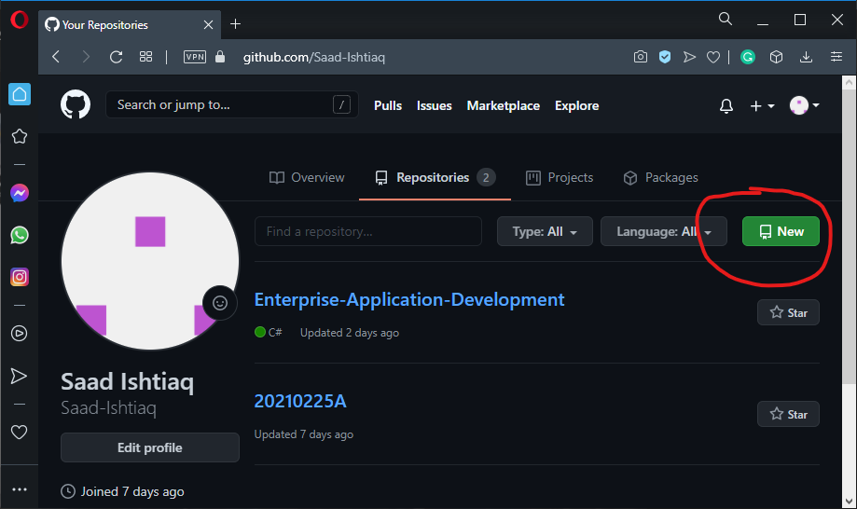

1. Give it a meaningful name. I am giving “MC_Progress”.

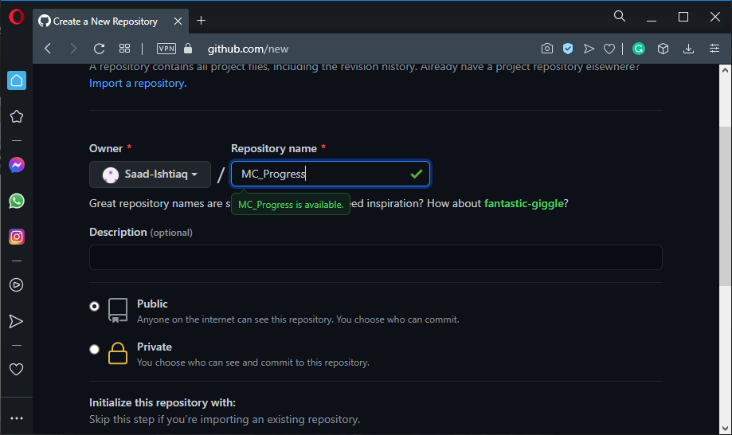

(Keep it public so that other people may get benefit.)

After configuring press “create repository” button.

1. Copy repository link. We need it in coming steps.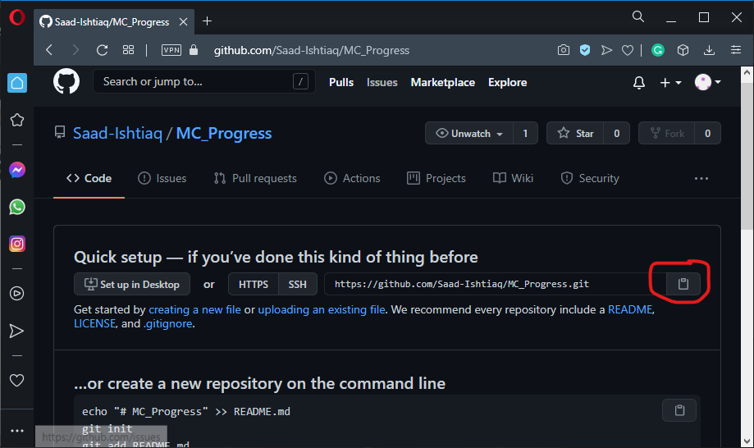
2. You must install git in you machine. Type “git install” on google. Download and install it.

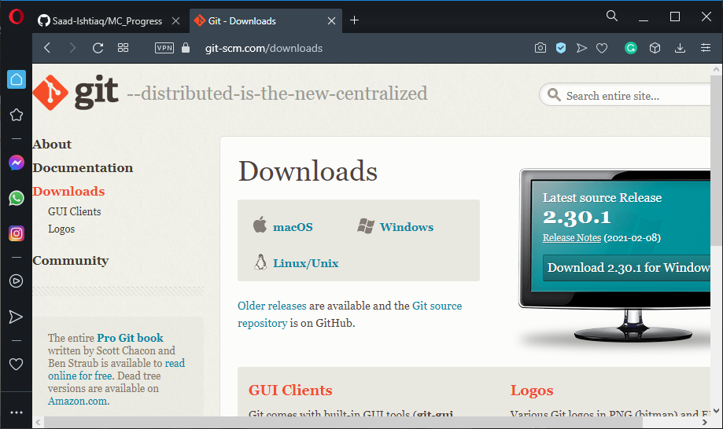

1. Now make a folder named as git.

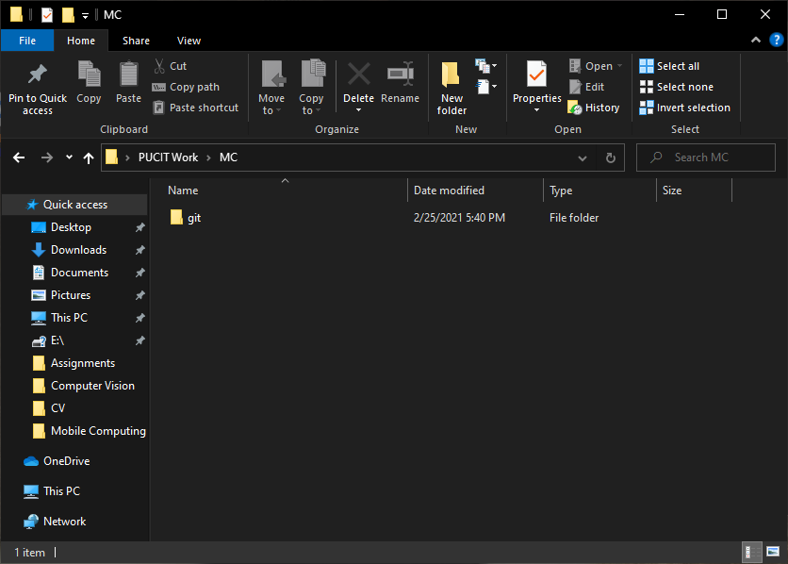

1. Now open cmd (run as administator)

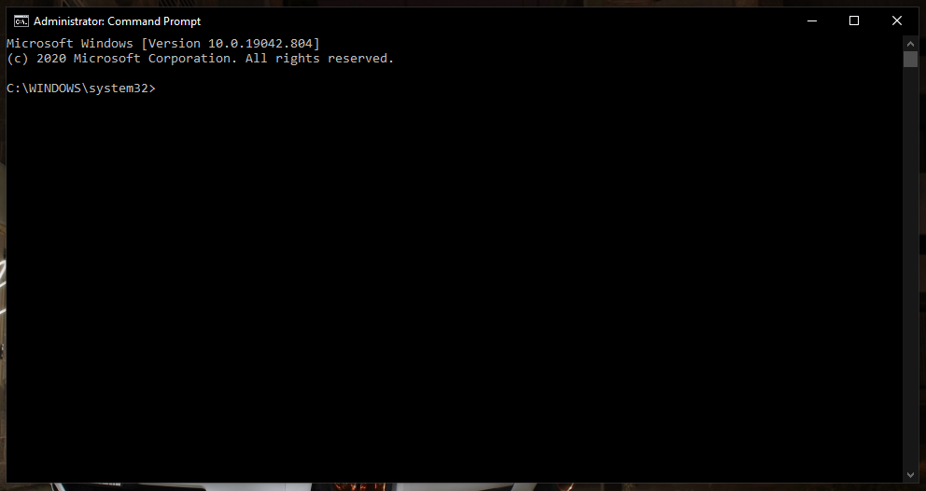

1. Use cd command and go to desired directory.

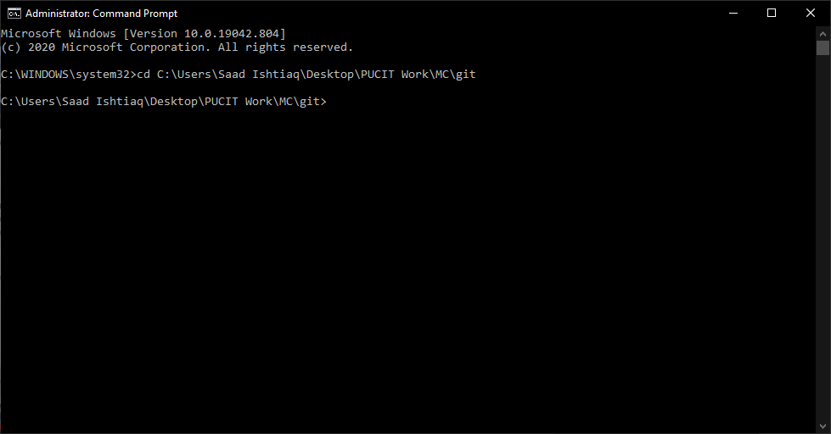

1. Write “git clone [parameter i.e url]”. Paste the link in place of parameter you previously coppied.

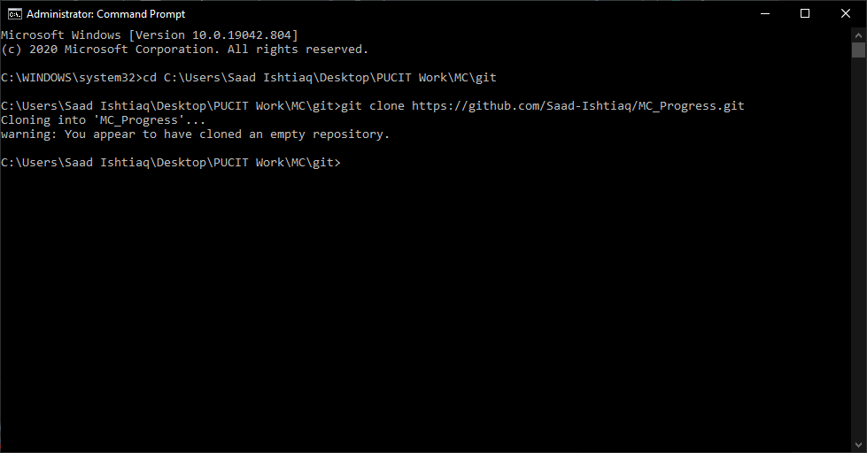

We have cloned the repository. Don,t bother about the warning message. It is just telling us that we have cloned an empty repository.

1. You will observe a folder automatically got created with the name of the repository.

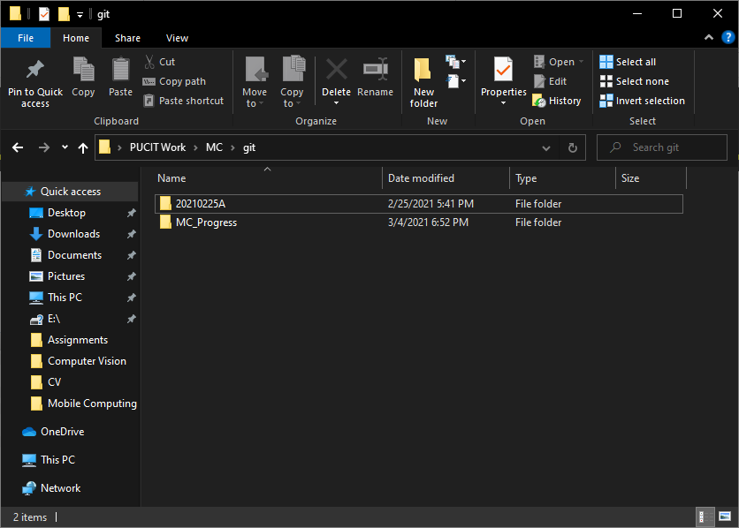

1. Lets make a .txt file to understand its communication with repository. Go to folder MC_Progress using cd. Write “git add [filename.ext]”.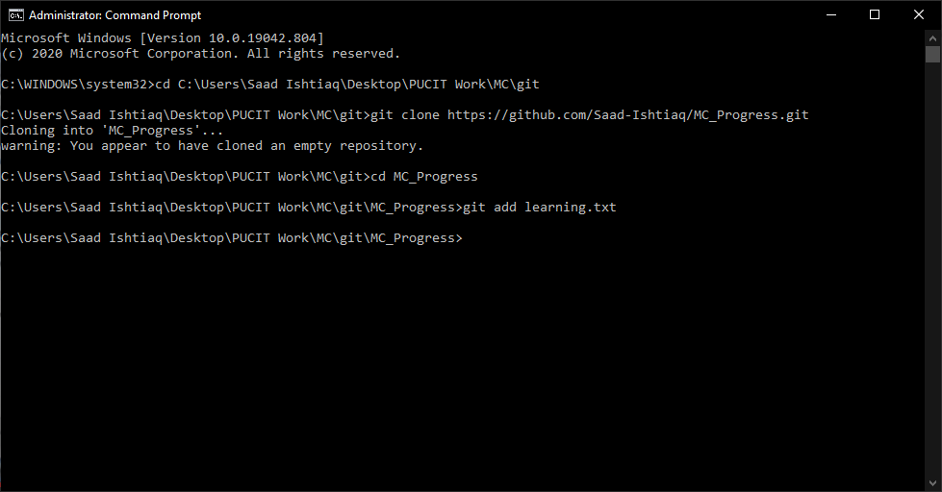

(you maybe asked to login your github id and password when use git command first time. Its is not an error just copy the commands given by cmd and paste it by changing your credentials)

1. Now type “git commit -m “Message” ”.

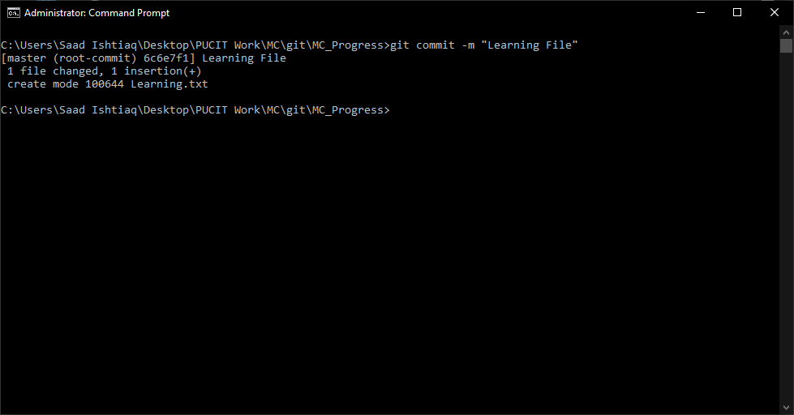

1. Now push the file to the repository by typing “git push”.

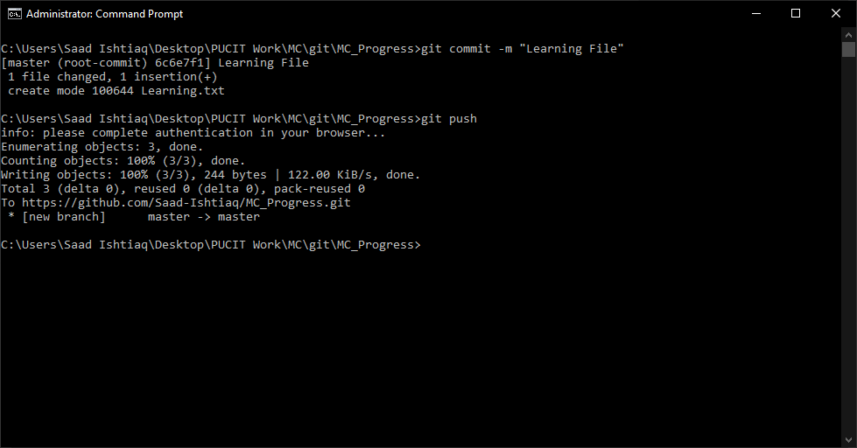

Now you can see the file in online repository.

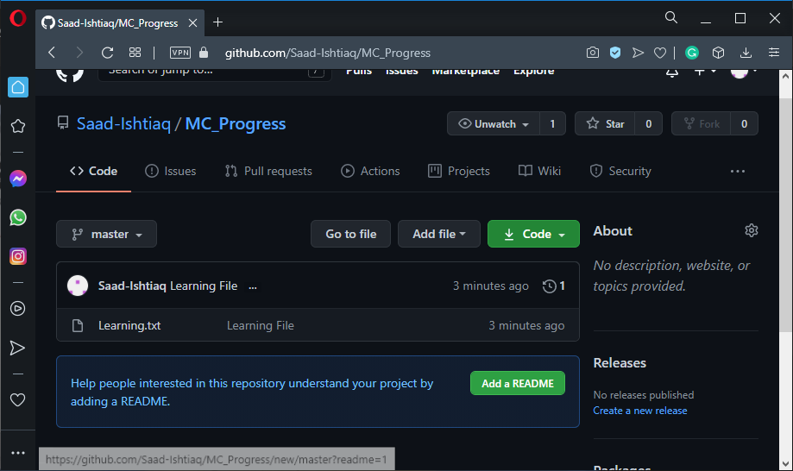

1. Today almost every IDE supports github and tells that we have made changed to the file. Lets open the file in VS code. When we write a line message pops. It also tells all the versions of our file.

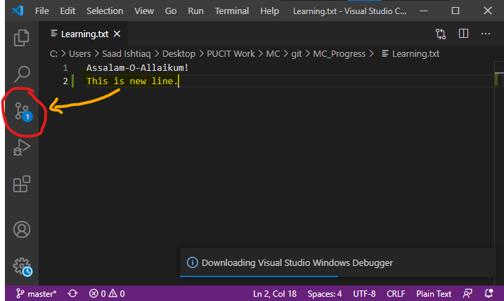

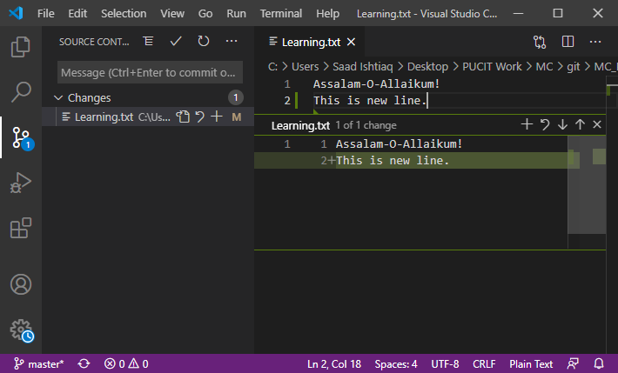

1. Moreover when we push the updated file by repeating same steps.We may see parent (previous versions) of our file

